



DEPARTMENT OF COMPUTER SCIENCE

COMPUTER NETWORK

LAB 5
DNS and Mail Server Configuration in Cisco Packet Tracer

Submitted By: | Submitted To: | Signature:
Name: Siddhant Shrestha CRN: 024bscit040 Semester: 4th  Section: B | Er. Sanjay Kumar Yadav Department of Computer Science St. Xavier’s College, Maitighar

Date of Submission: 08/11/2026

Lab No. 2

Title: Windows Networking Utilities and DHCP Network Configuration Lab 2.1: Study of Windows Networking Commands
Objective: To study and perform various Windows Command Prompt utilities used for network configuration, troubleshooting, monitoring, and administration.

Theory
Windows includes a set of built in command line networking tools that help administrators configure, monitor, troubleshoot and manage network resources. Using these commands, users can check IP settings, verify connectivity, resolve hostname/DNS issues, trace routing paths, view active connections and control network related services.

Key Commands used:

- ipconfig
Shows the computer's current TCP/IP settings, including IP address, subnet mask, and default gateway.
Syntax: ipconfig

ipconfig /all
a full view of network configuration details such as MAC address, DHCP status, DNS servers, lease duration, and adapter information.
Syntax: ipconfig /all

ipconfig /release
the IP address currently assigned by the DHCP server.
Syntax: ipconfig /release

ipconfig /renew
Obtains a new IP address from the DHCP server.
Syntax: ipconfig /renew

ipconfig /flushdns
Removes all cached DNS entries stored on the local machine
Syntax: ipconfig /flushdns

ping
Checks connectivity between two devices by sending ICMP Echo Request packets.
Syntax: ping <IP Address>
Example: ping 10.10.10.10

ping -t
Sends ping request repeatedly until stopped manually with Ctrl + C.
Syntax: ping <IP Address> -t Example: ping 192.168.1.1 -t
- ping -l <size> -t
Sends continuous ping requests with a custom packet size. Syntax: ping <IP Address> -l <packet_size> -t
Example: ping 192.168.1.1 -l 1000 -t

tracert
Shows the route packets take from the source device to the destination.
Syntax: tracert <IP Address> Example: tracert youtube.com

nslookup
Looks up the IP address associated with a given domain name by querying DNS servers.
Syntax: nslookup <domain_name> Example: nslookup google.com

netstat
Displays active network connections along with general network statistics.
Syntax: netstat

netstat -an
Lists all active connections and listening ports in numeric form.
Syntax: netstat -an

netstat /?
Displays help information and available parameters for the netstat command.
Syntax: netstat /?

arp -a
Displays the Address Resolution Protocol (ARP) cache containing IP-to-MAC address mappings.
Syntax: arp -a

hostname
Displays the name assigned to the local computer.
Syntax: hostname

getmac
Displays the MAC addresses of network adapters installed on the computer.
Syntax: getmac

net share
Lists the folders and resources currently shared from the computer.
Syntax: net share

net start
List the Windows services that are currently running.
Syntax: net start

net stop
Stops a specified Windows service. Syntax: net stop <service_name>

Components Required
- Computer System
- Windows Operating System
- Command Prompt (CMD)
- Network Connection

Procedure:

Opening Command Prompt
  - Press Windows + R.
  - Type cmd and press Enter.
  - The Command Prompt window will open.
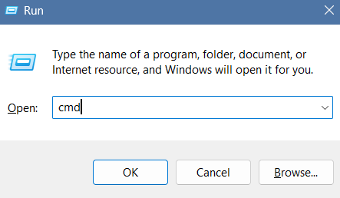

Viewing Basic IP Configuration
  - Open Command Prompt.
  - Execute: ipconfig
  - Observe the IP address, subnet mask, and default gateway.

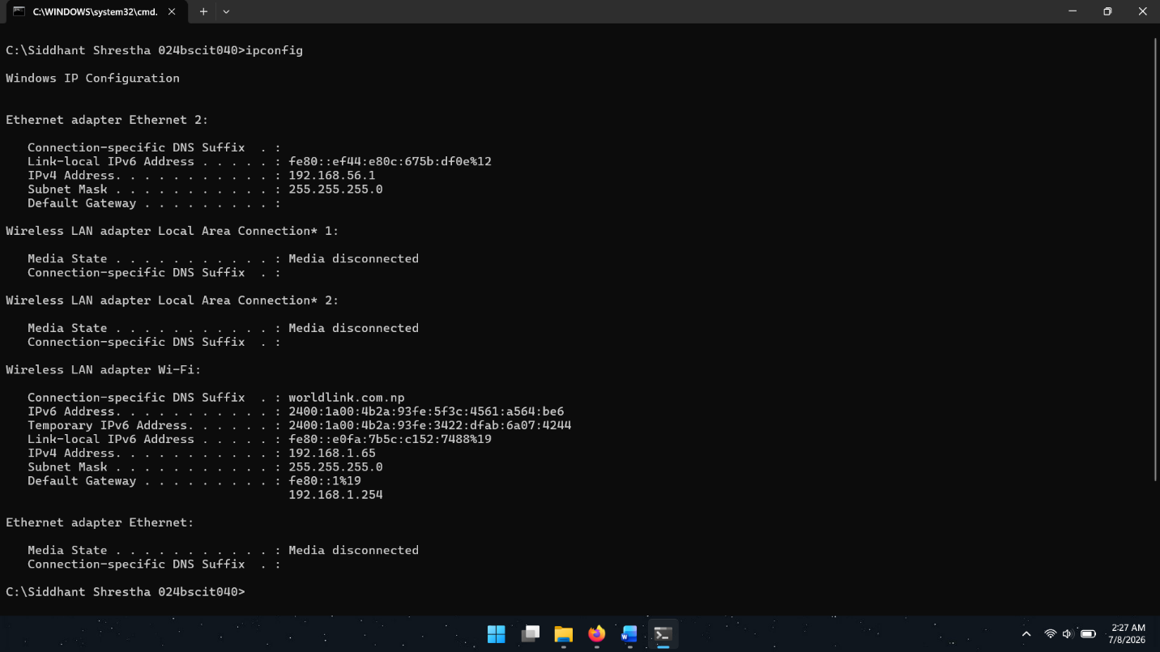
Output:

Viewing Detailed Network Information
  - Execute: ipconfig /all
  - Observe the MAC address, DHCP status, DNS server, and lease information.

Output:

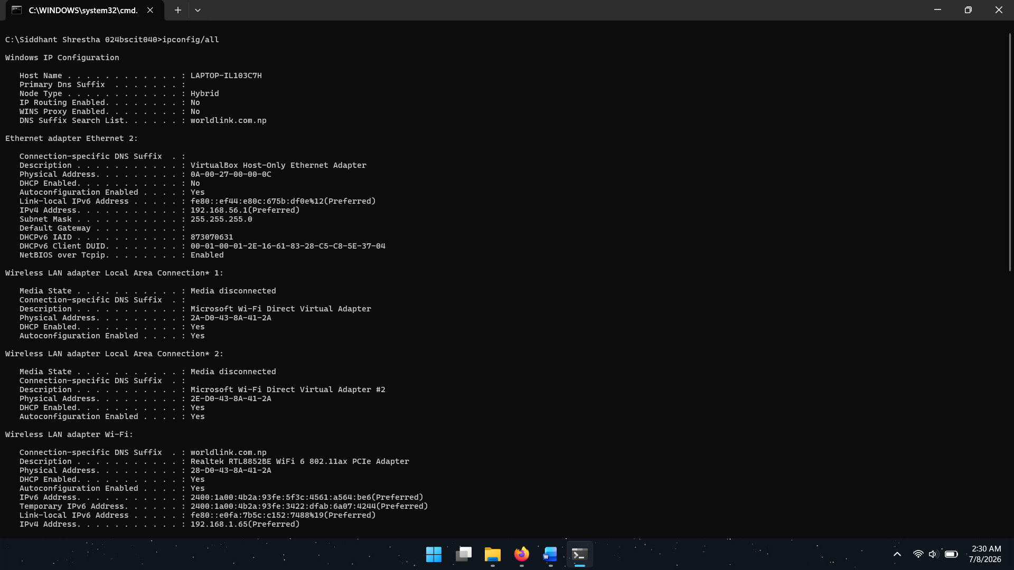

Releasing and Renewing IP Address
- Release the current IP address: ipconfig /release
- Observe that the IP configuration is removed.
- Obtain a new IP address: ipconfig /renew
- Verify the newly assigned IP address.

Output:
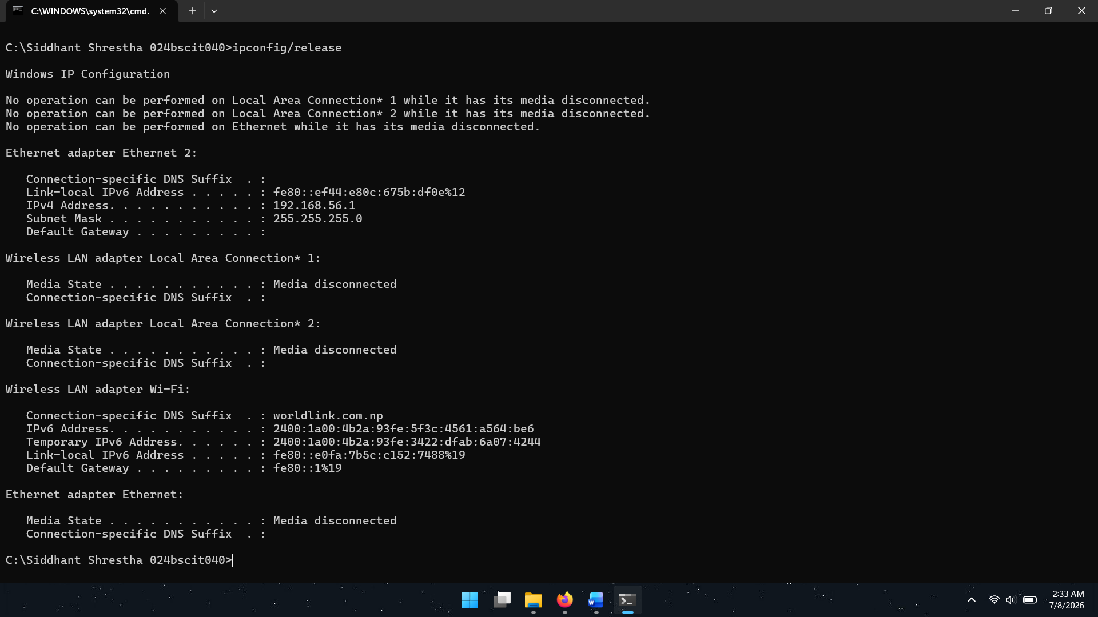

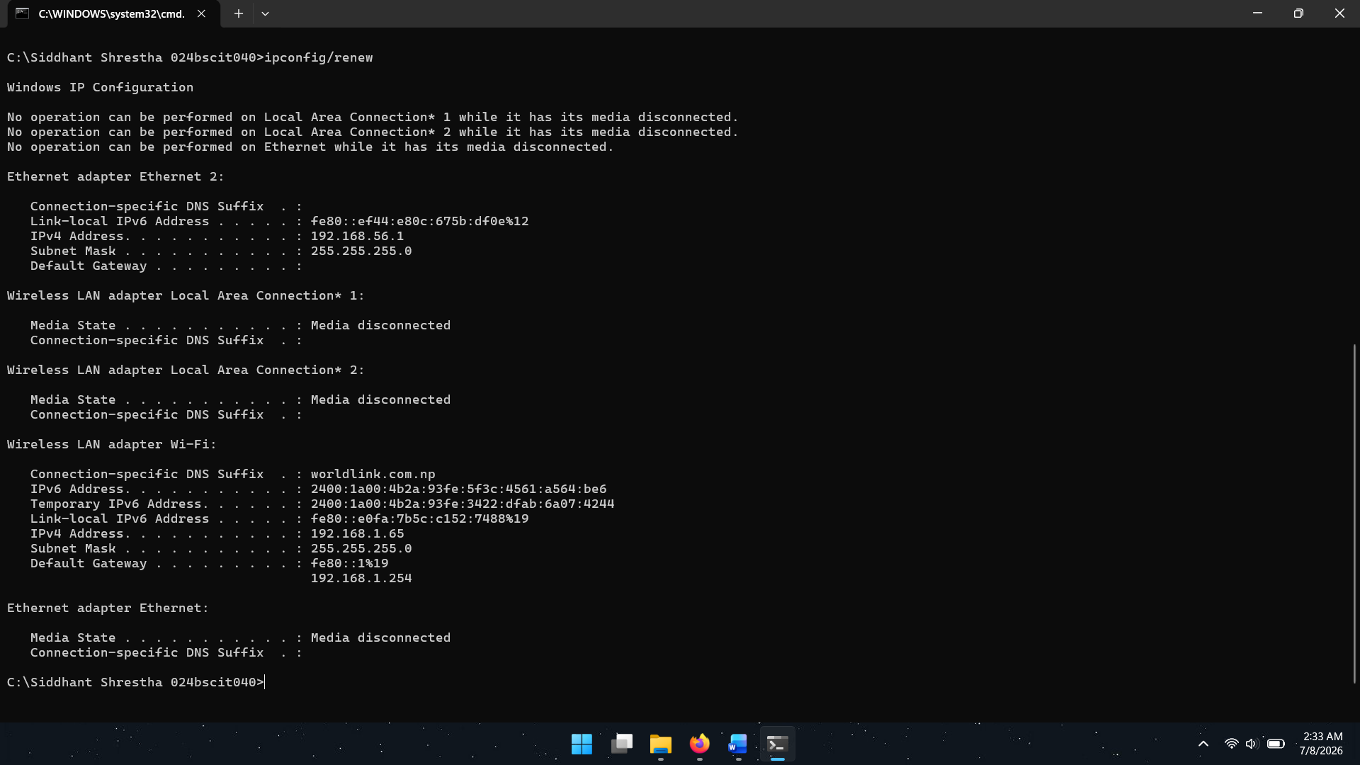

Clearing DNS Cache
- Execute: ipconfig /flushdns
- Verify that the DNS Resolver Cache is successfully flushed.

Output
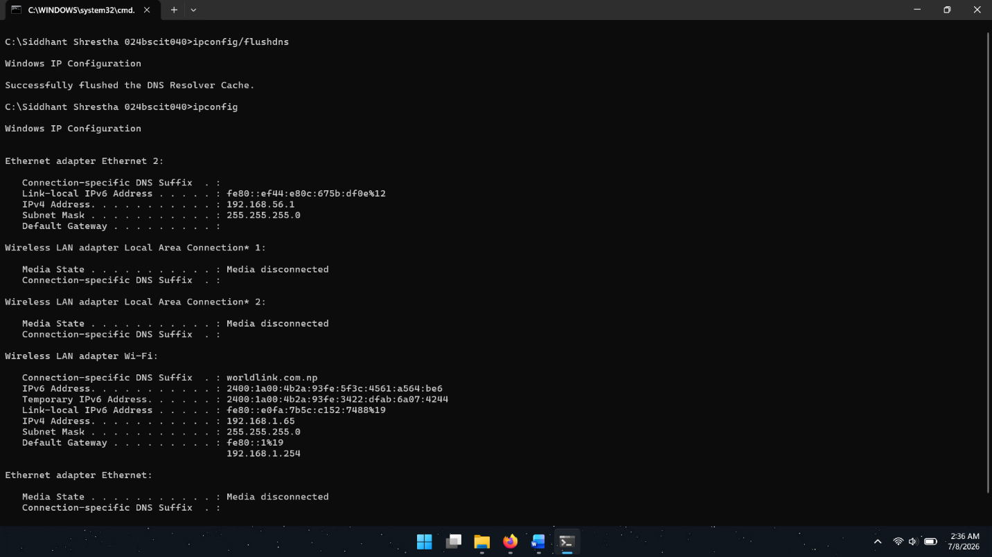

Testing Network Connectivity
- Execute: ping google.com and ping sxc.edu.np
Output:
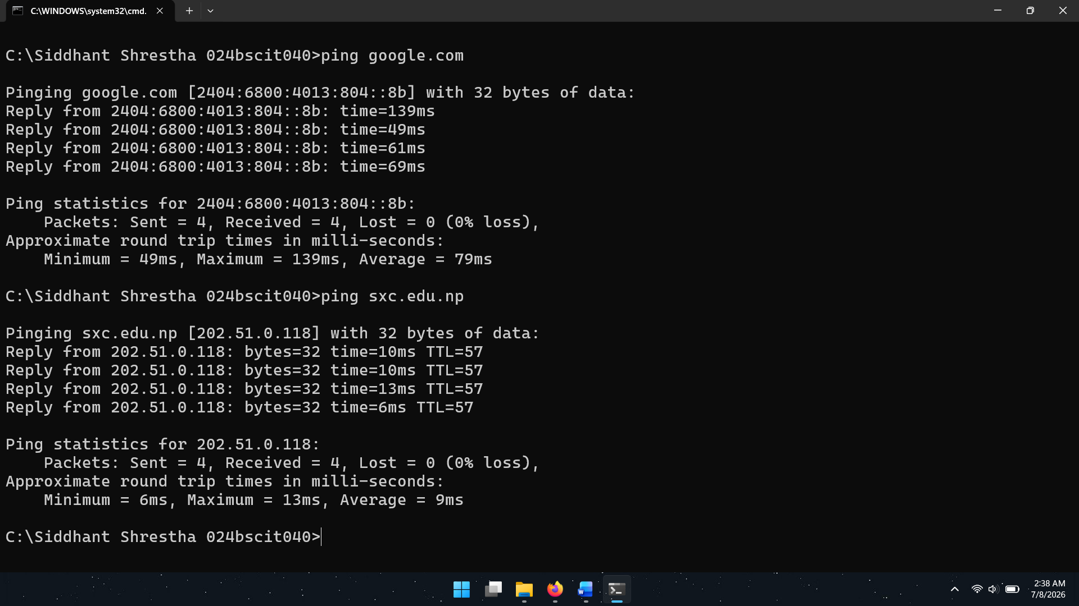

- Observe reply packets and round-trip time.
- Execute continuous ping: ping google.com -t
- Stop the process using Ctrl + C.

Output:

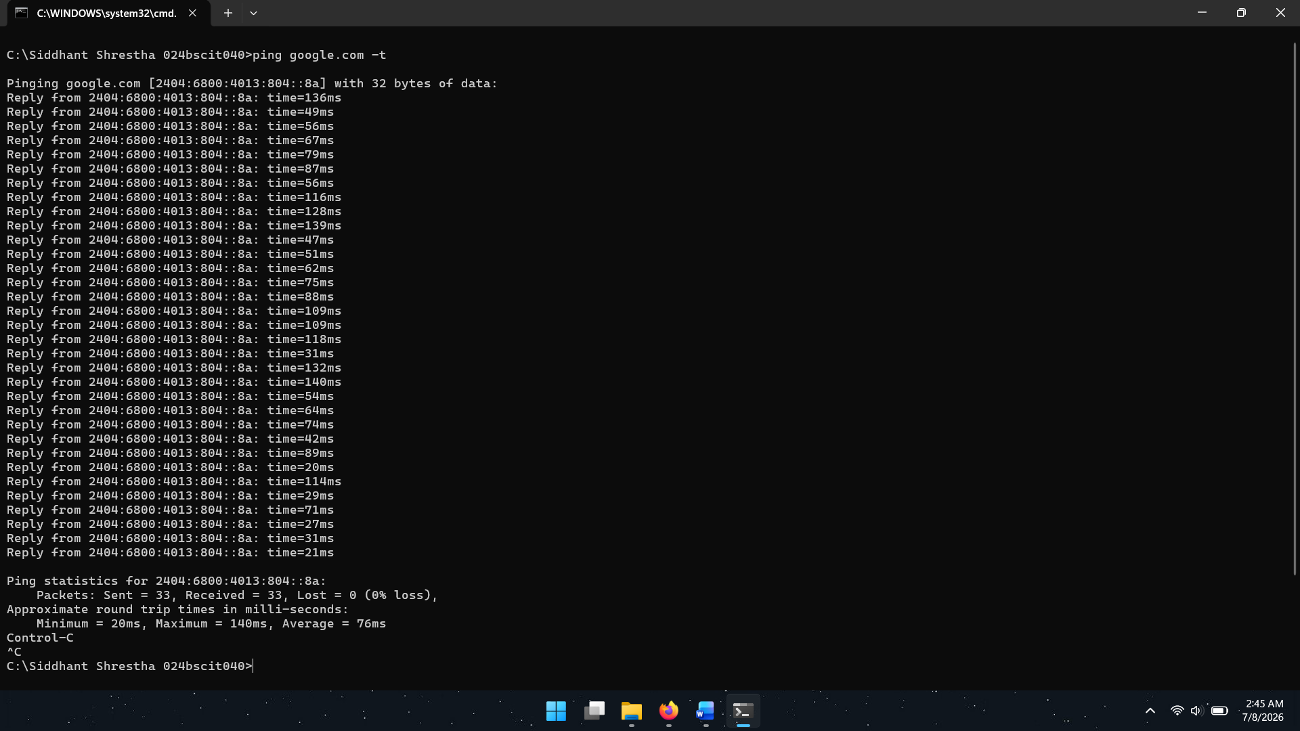

Testing Packet Size
- Execute: ping google.com –l 1500 –t
- Observe the transmission of larger packets.
- Stop using Ctrl + C.

Output:
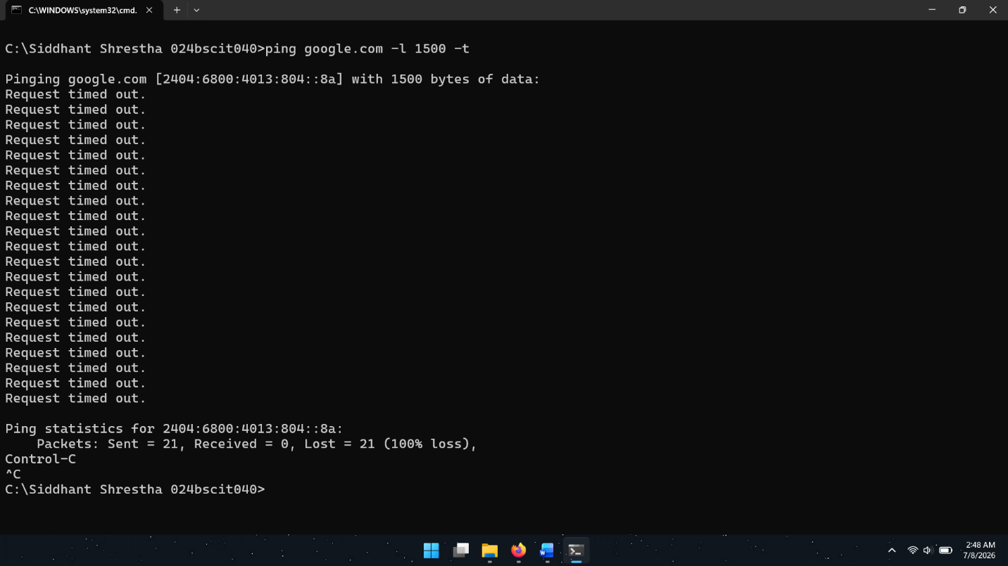
- Execute: ping google.com –l 512 –t
- Observe the transmission of larger packets.
- Stop using Ctrl + C.

Output:
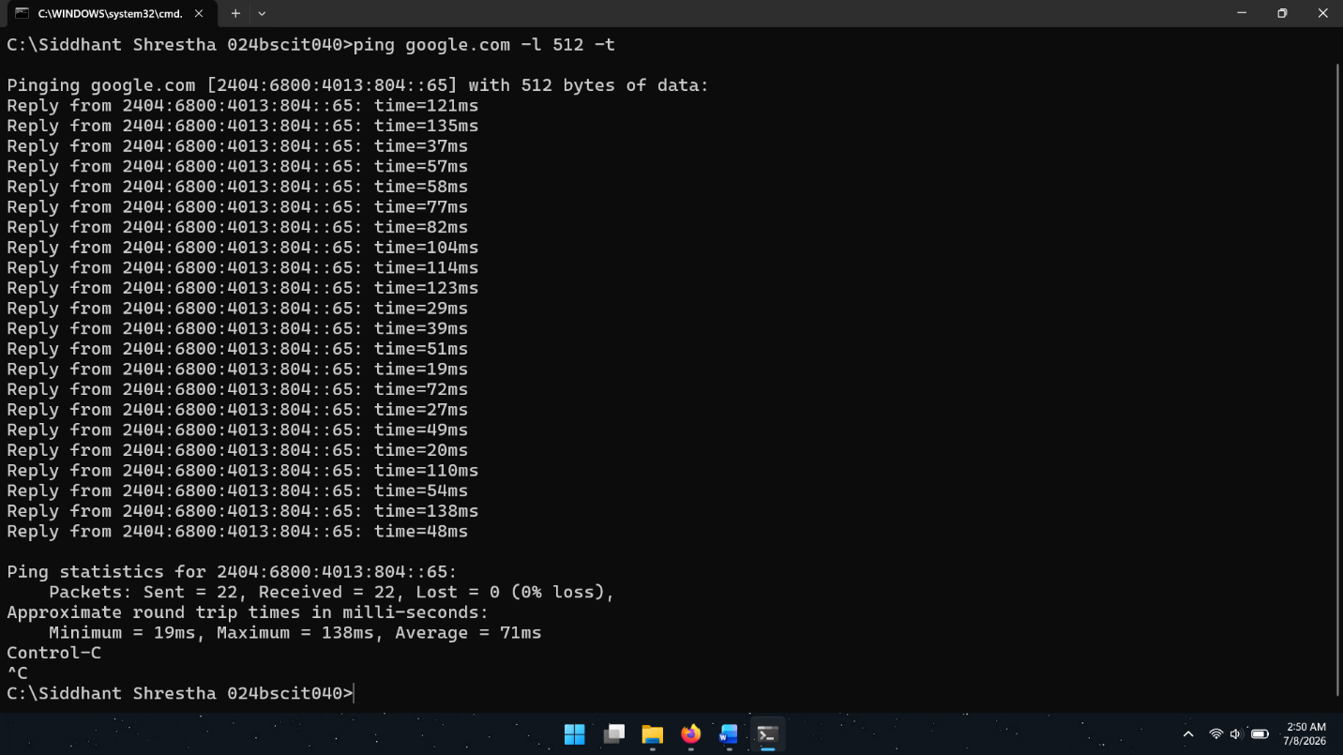

Tracing Network Route
- Execute: tracert youtube.com
- Observe intermediate routers and hop counts.

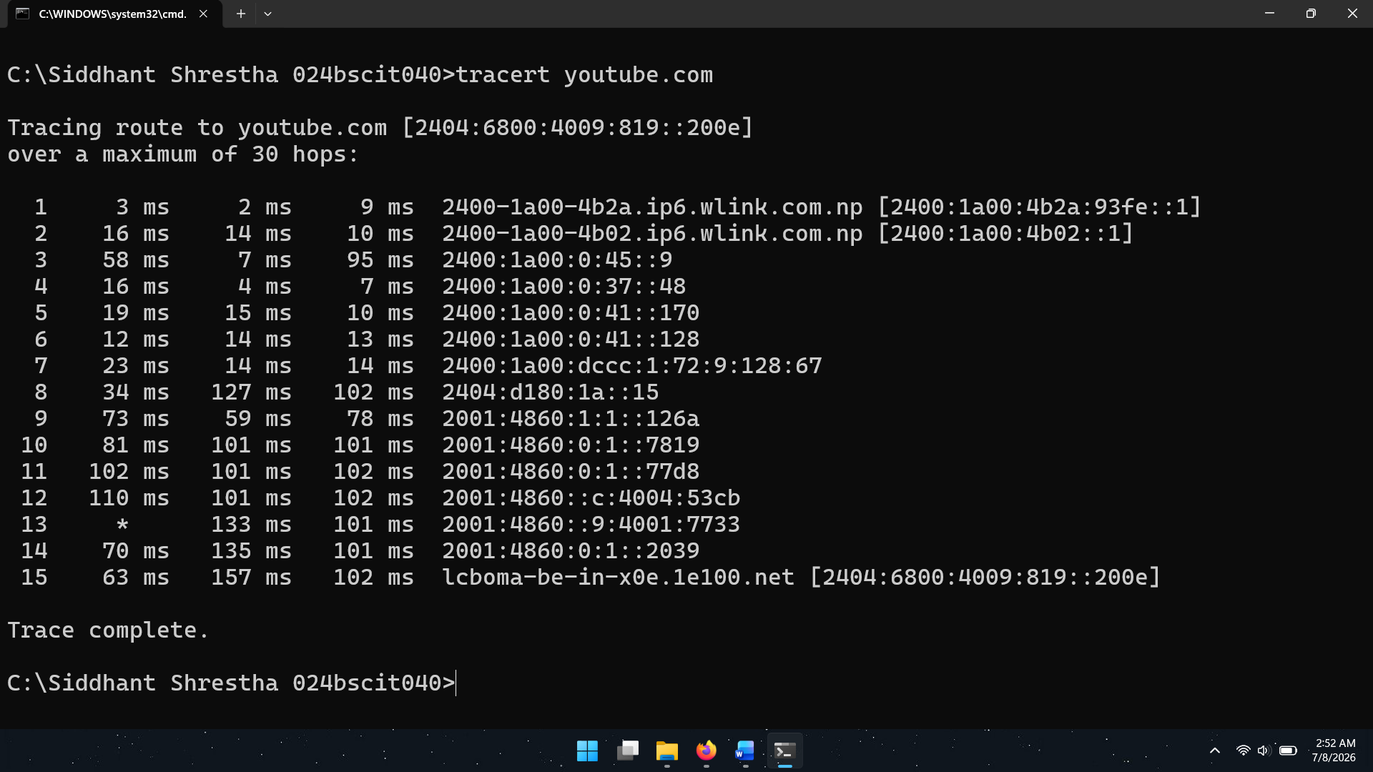
Output:

DNS Name Resolution
- Execute: nslookup google.com
- Observe the corresponding IP address returned by the DNS server.

Output:
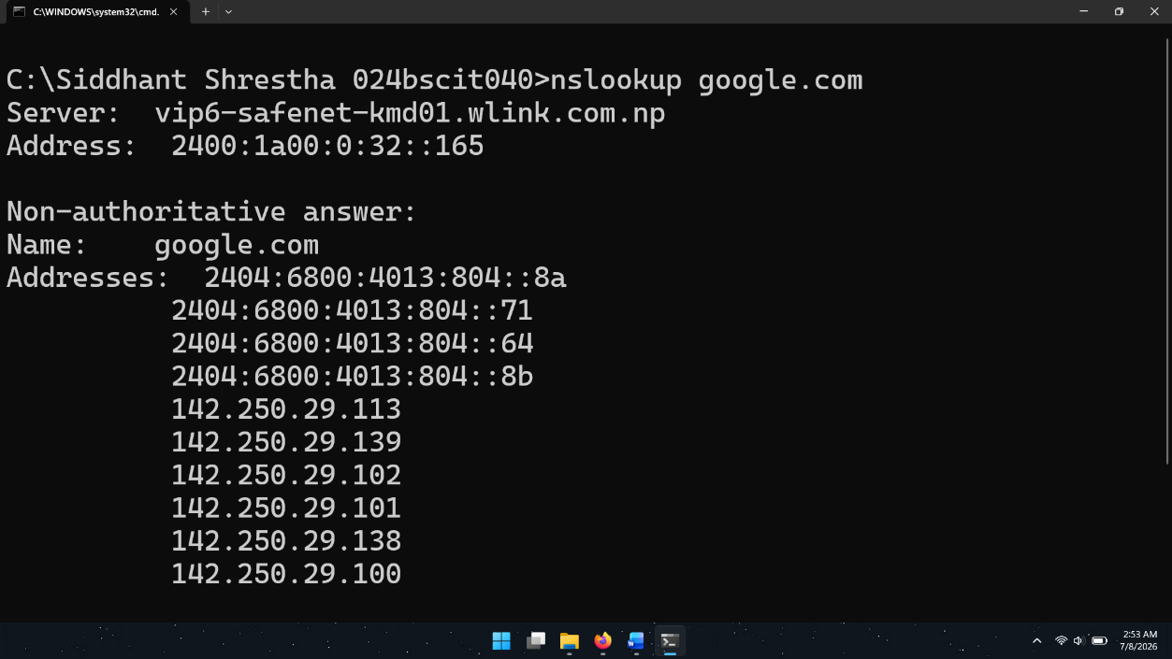

Monitoring Active Connections
- Execute: netstat
- Observe active network connections.

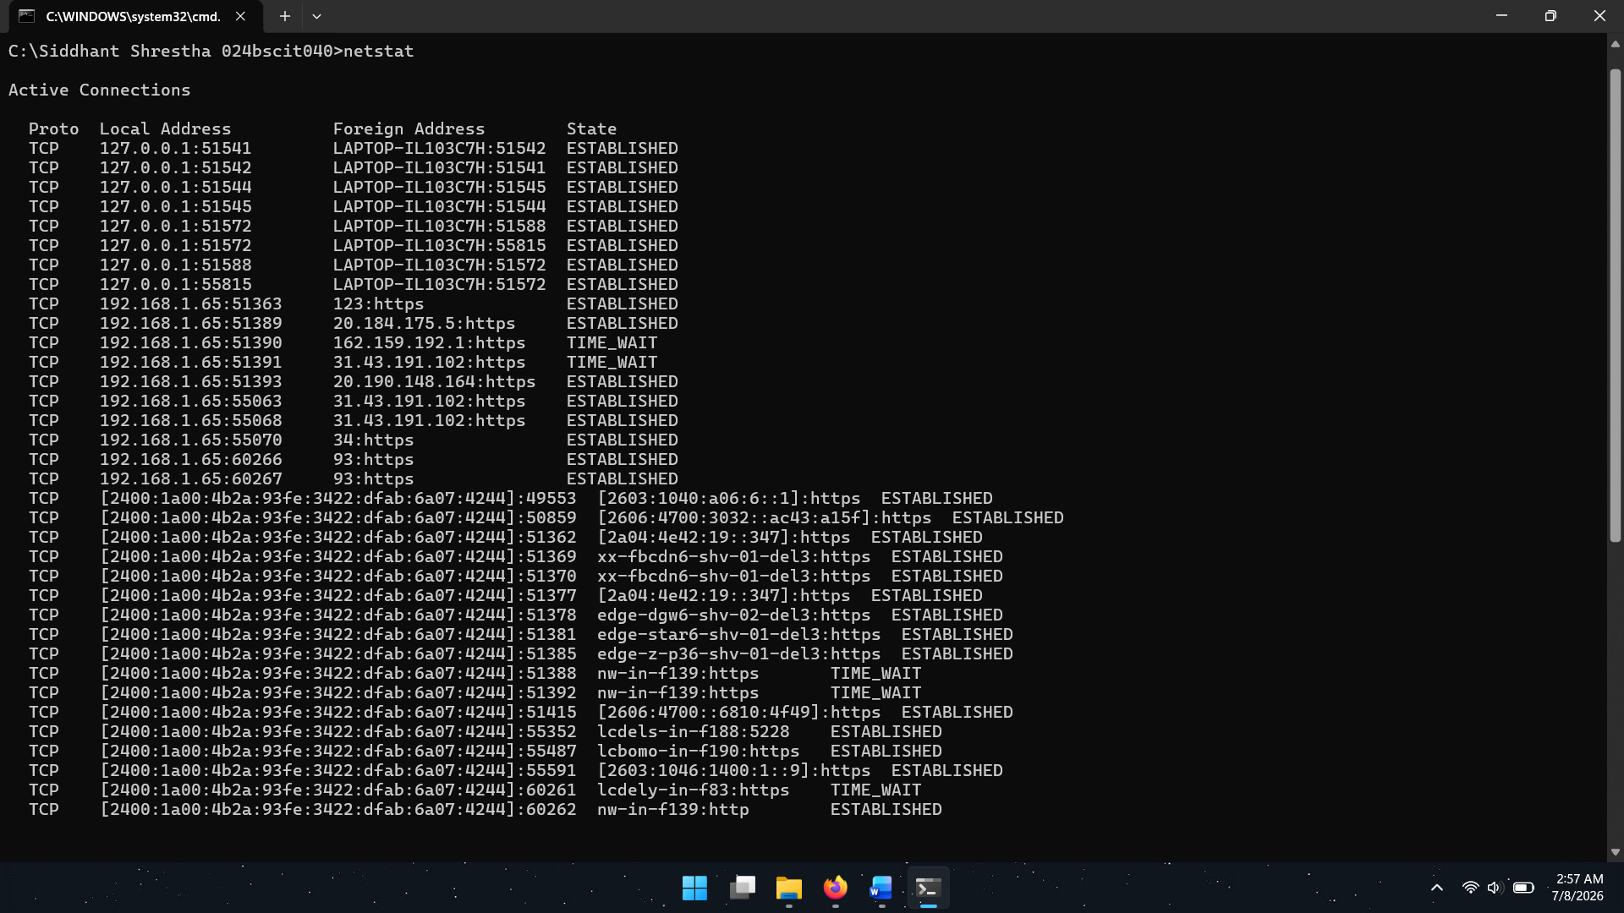
Output:

- Execute: netstat -an
- Observe listening ports and numerical addresses.

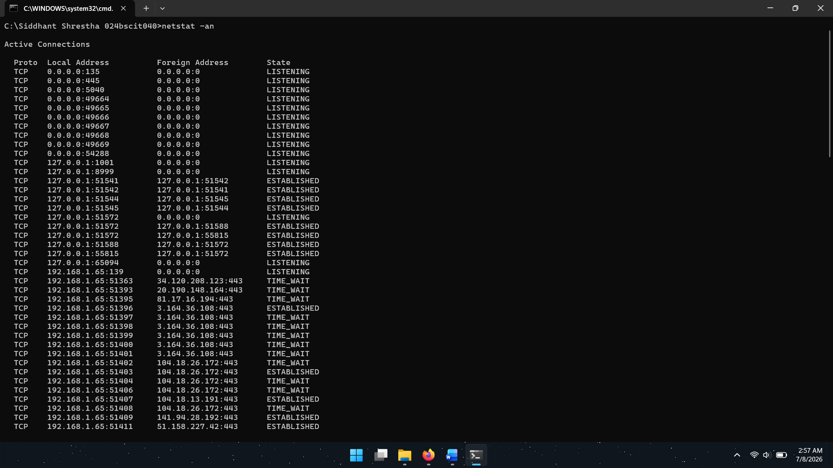
Output:

Viewing ARP Cache
- Execute: arp -a
- Observe IP-to-MAC address mappings.

Output:
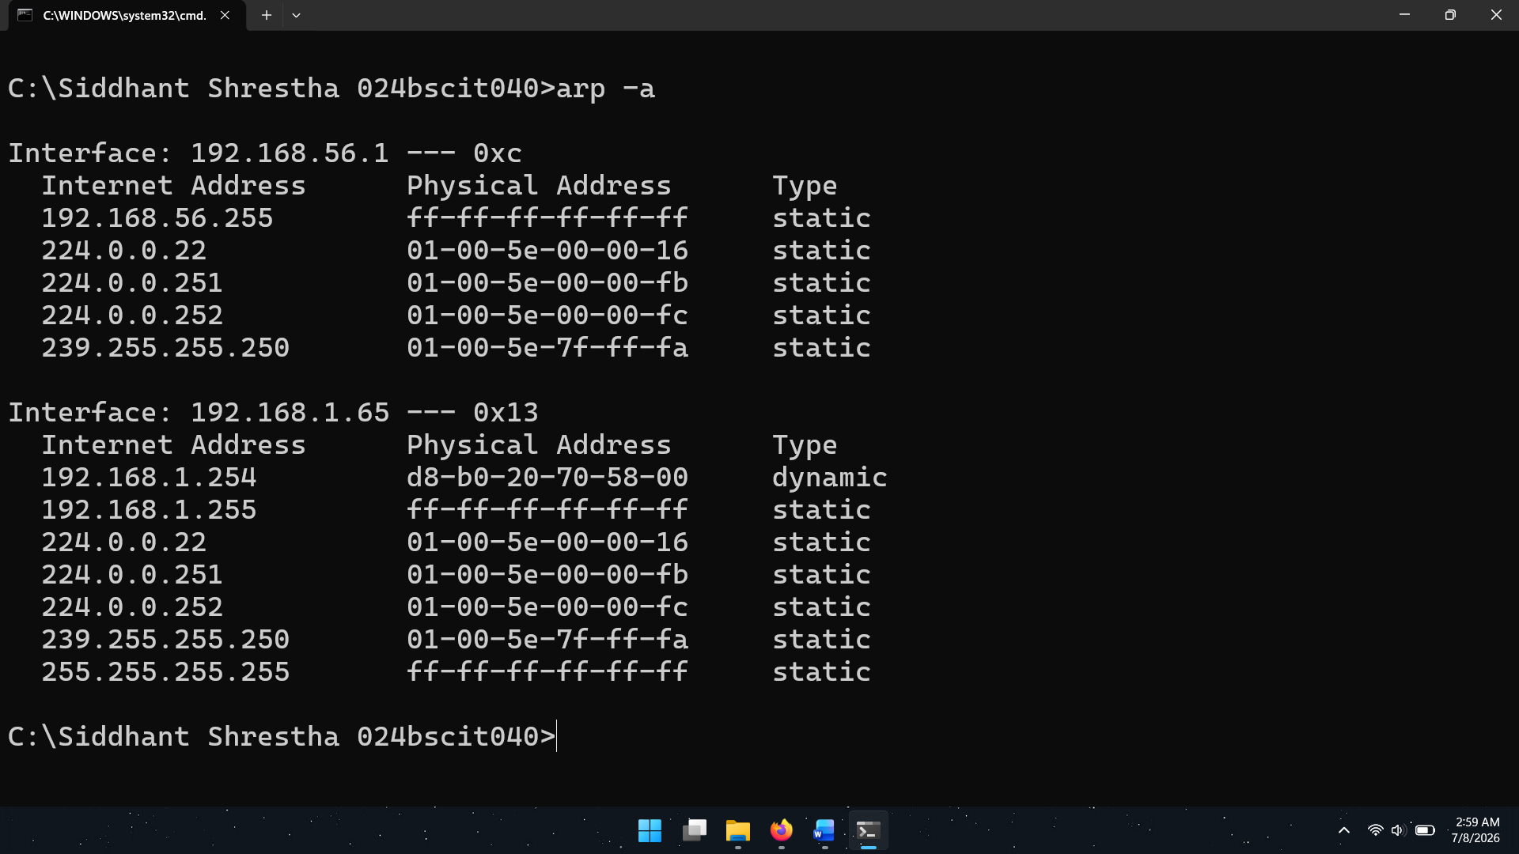

Viewing Host Information and Shared Resources
- Display computer name: hostname
- Display MAC addresses: getmac
- Execute: net share
- Observe available shared folders and resources.

Output:
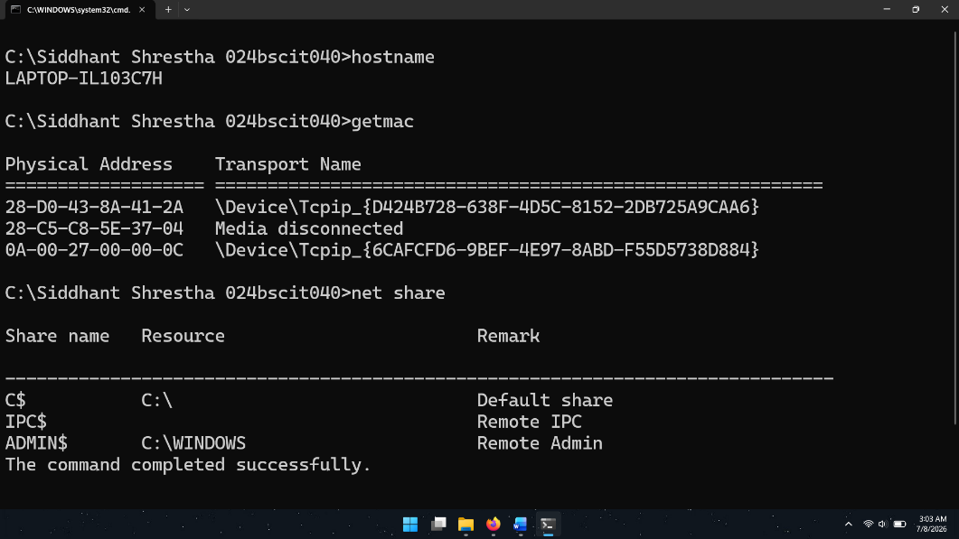

Managing Services
  - Display running services: net start

Output:

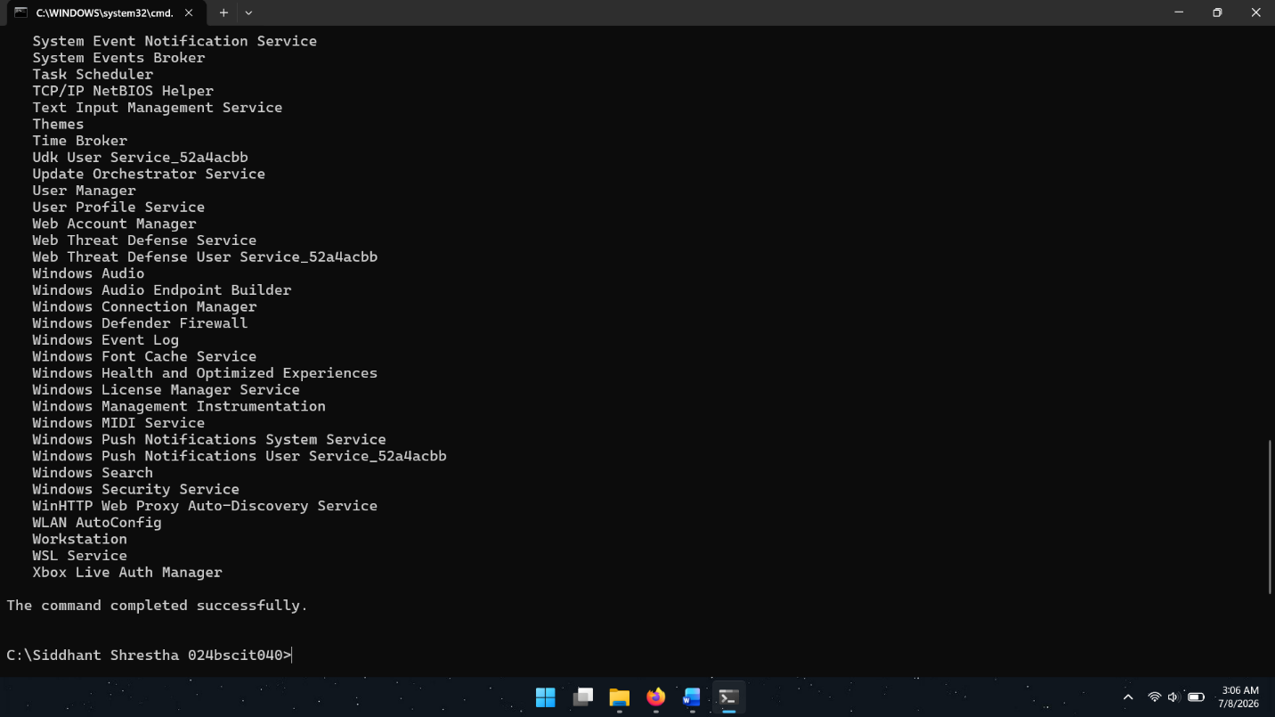
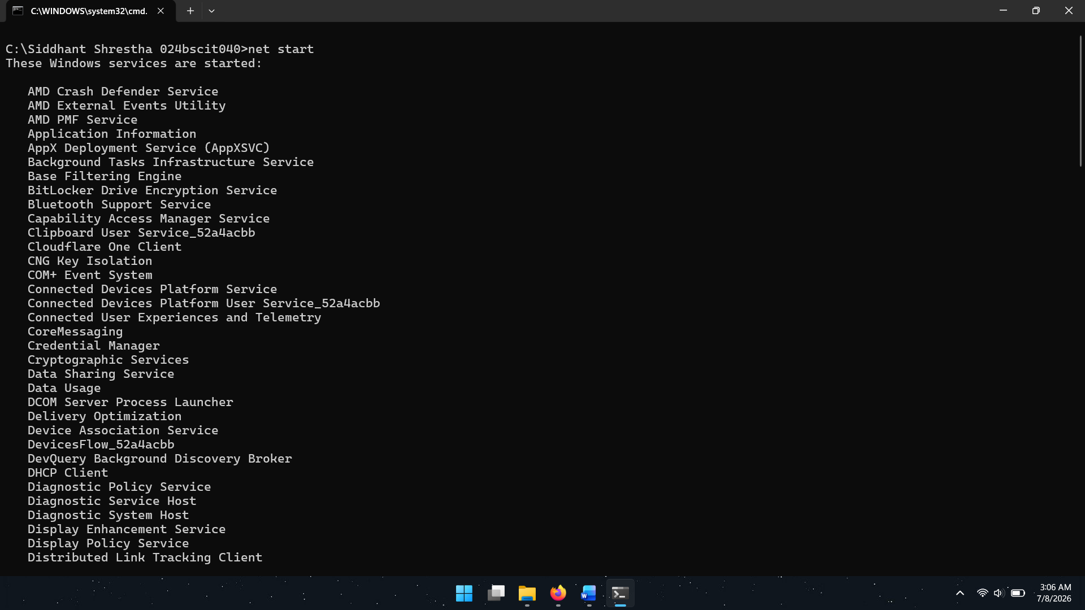

  - Stop a service (administrator privileges may require):
net stop <service_name>
Example: net stop themes

Output:

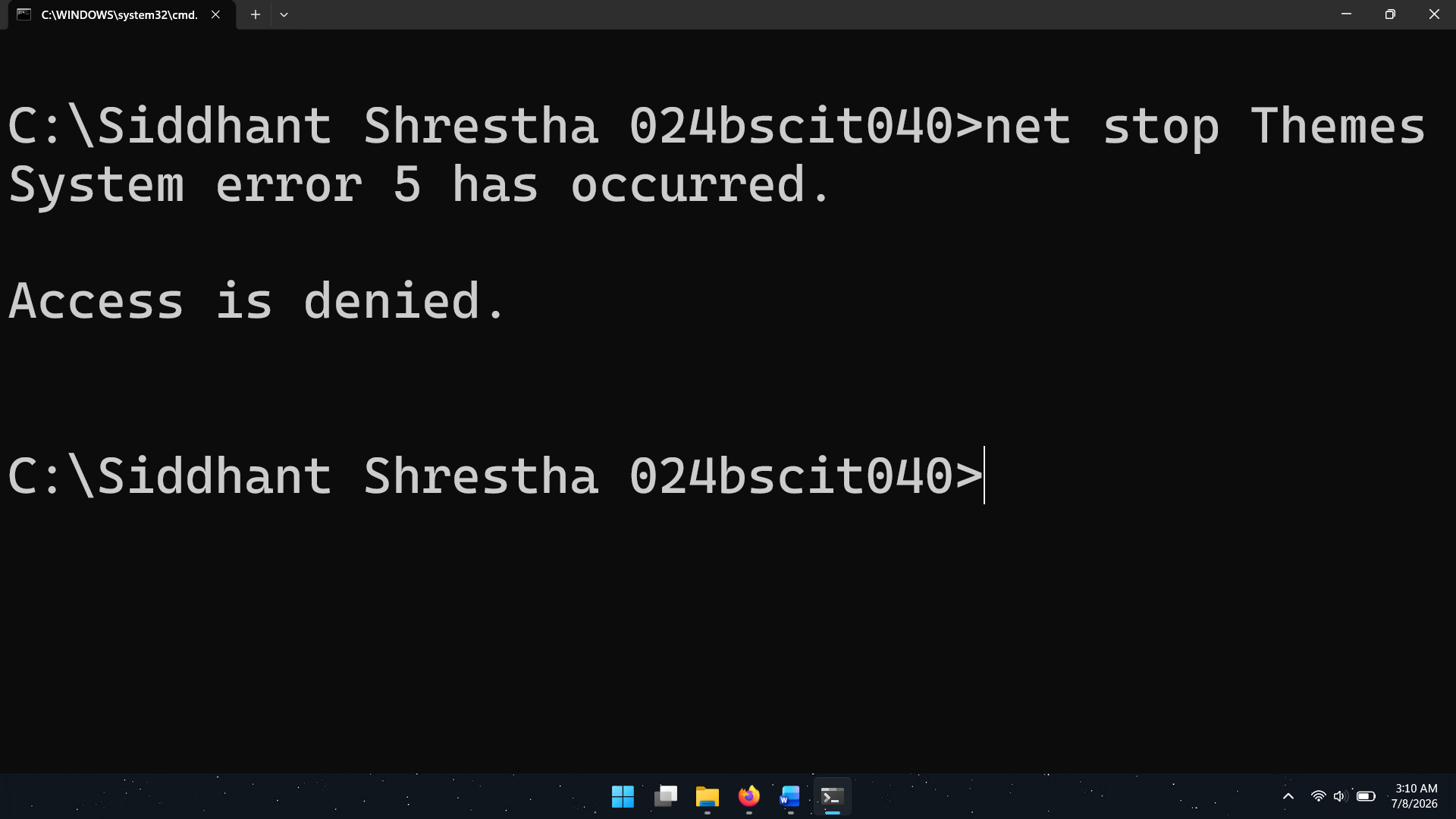

Lab 2.2: DHCP Server Configuration and Dynamic IP Address Allocation Using Cisco Packet Tracer
Objective: To configure a DHCP server and verify automatic IP address allocation to network devices using Cisco Packet Tracer.

Theory
In Lab 1, each device on the network was configured with a manually assigned (static) IP address. Although static addressing works well for small networks, it becomes increasingly difficult to manage as the number of devices grows. Dynamic Host Configuration Protocol (DHCP) addresses this problem.
DHCP is an application-layer protocol that automatically assigns IP addresses along with other network settings—such as subnet mask, default gateway, and DNS server addresses—to client devices. This reduces the administrative burden on network staff and helps prevent configuration mistakes.

DHCP Components
- DHCP Server
A DHCP Server maintains a pool of IP addresses and hands them out to client devices when requested.

DHCP Client
Any device on the network that automatically requests an IP address from the DHCP server.

DHCP Scope
The range of IP addresses available for assignment. Example:
Network: 192.168.1.0/24
Range: 192.168.1.2 – 192.168.1.254
Gateway: 192.168.1.1

DHCP Process (DORA) Discover
The client sends out a DHCP Discover broadcast message to find any available DHCP servers.

Offer
The DHCP responds by offering an available IP address.

Request
The client sends a request for the offered IP address.

Acknowledgement
The DHCP server confirms the assignment. This sequence is commonly known as DORA:
Discover → Offer → Request → Acknowledge

Components Required
- Router
- Switch
- Server
- PCs/Laptops
- Copper Straight-Through Cable

Procedure:

Creating the Network Topology
  - Open Cisco Packet Tracer.
  - Place the following devices in the workspace:
    - One Router
    - One Switch
    - One Server
    - Two PCs
    - Two Laptops
  - Connect all devices to the switch using Copper Straight-Through Cables.
  - Connect the router to the switch.

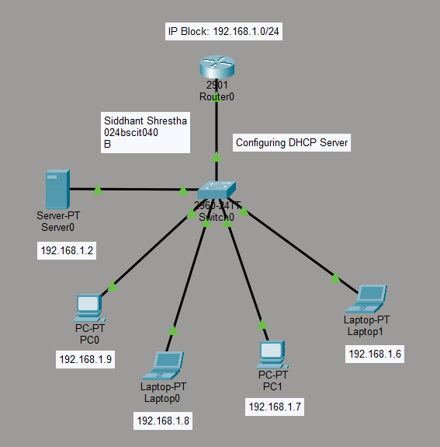

Configuring the Router
  - Open the Router CLI.
  - Enter privileged mode: Router> enable
  - Enter configuration mode: Router# conf t
  - Configure the router interface:
Router(config)# hostname siddhantshrestha
siddhantshrestha(config)# interface gigabitEthernet 0/1
siddhantshrestha (config-if)# ip address 192.168.1.1 255.255.255.0
siddhantshrestha (config-if)# no shutdown
  - Save the configuration.
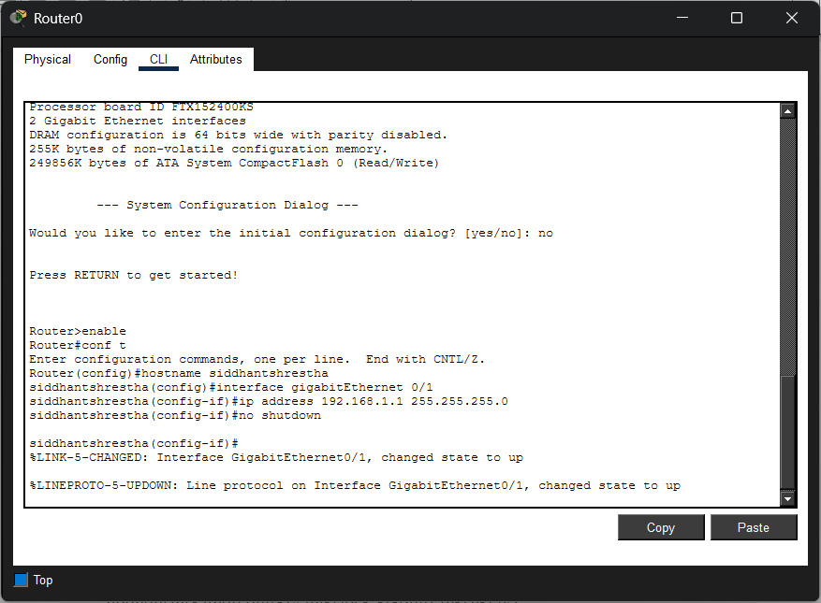

Configuring DHCP on the Router
  - Open the Router CLI and enter global configuration mode.
siddhantshrestha> enable
siddhantshrestha# configure terminal
  - Create a DHCP pool: siddhantshrestha (config)# ip dhcp pool siddhant
  - Configure the network, gateway, and DNS server:
siddhantshrestha (dhcp-config)# network 192.168.1.0 255.255.255.0
siddhantshrestha (dhcp-config)# default-router 192.168.1.1
siddhantshrestha (dhcp-config)# dns-server 10.10.10.10
siddhantshrestha (dhcp-config)# exit
  - Exclude reserved IP addresses:
siddhantshrestha(config)# ip dhcp excluded-address 192.168.1.1 192.168.1.5
  - Save the configuration:
siddhantshrestha # wr

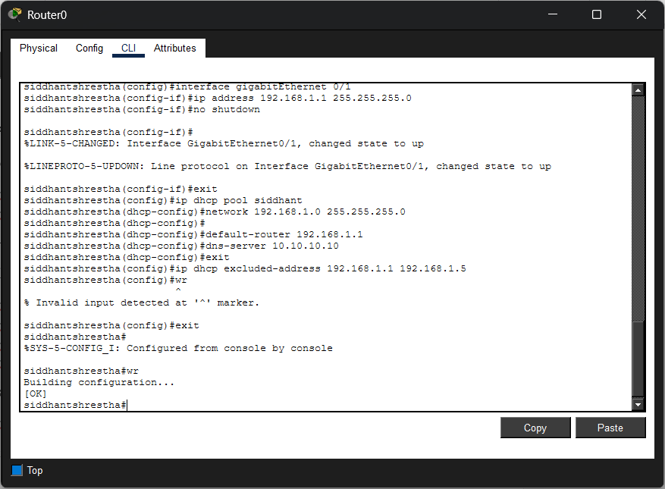

Configuring the DHCP Server
  - Open the Server.
  - Navigate to: Services → DHCP
  - Turn the DHCP service ON.
  - Create a DHCP pool.
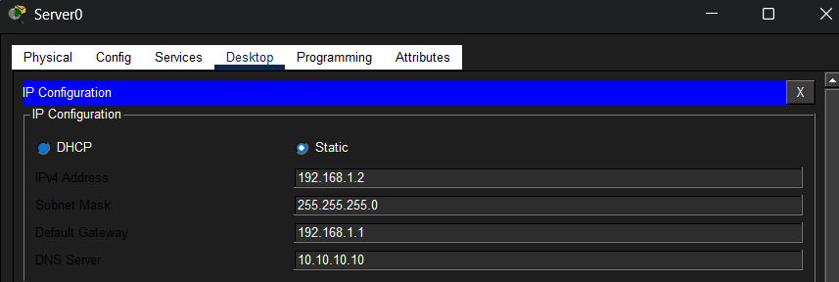
  - Click Add to create the pool.

Configuring Clients
  - Open each PC and Laptop.
  - Navigate to: Desktop → IP Configuration
  - Select: DHCP
  - Wait for the device to obtain an IP address automatically.
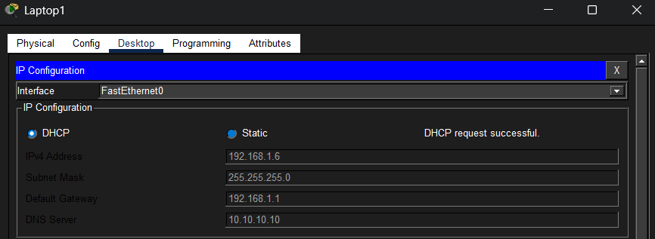
  - Verify that valid IP addresses have been assigned.
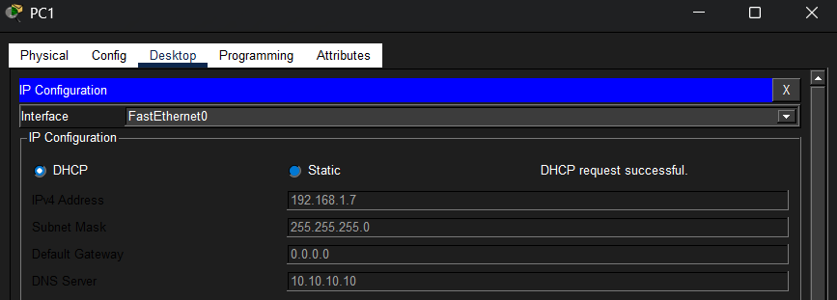
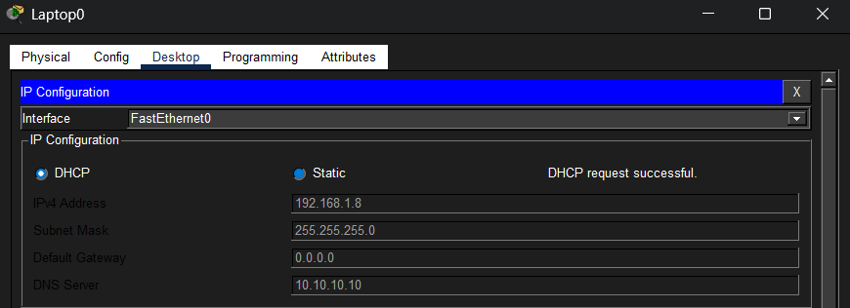

Testing Connectivity
    - Open Command Prompt on a client device (P0)
    - Ping the router: ping 192.168.1.1
    - Ping the server: ping 192.168.1.2
    - Verify successful replies.
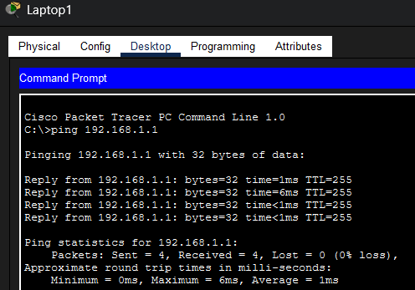
Fig: Pinging the router (192.168.1.1) from Laptop1 (192.168.1.6)

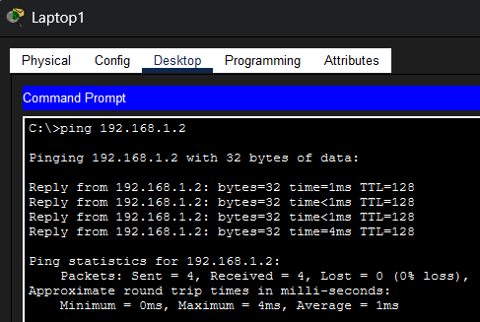
Fig: Pinging the server (192.168.1.2) from Laptop1 (192.168.1.6)

Simulation Verification
    - Switch Packet Tracer to Simulation Mode.
    - Generate network traffic using the ping command. (pinging Laptop1 to PC0)
    - Observe packet exchange between the DHCP server and clients.
    - Verify successful network communication.

Output

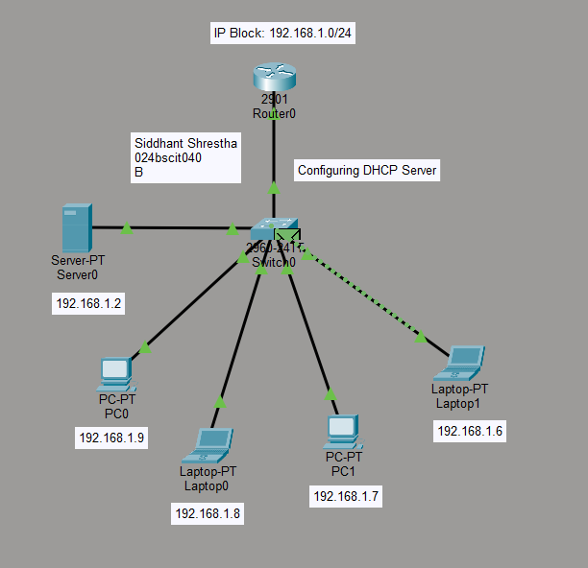
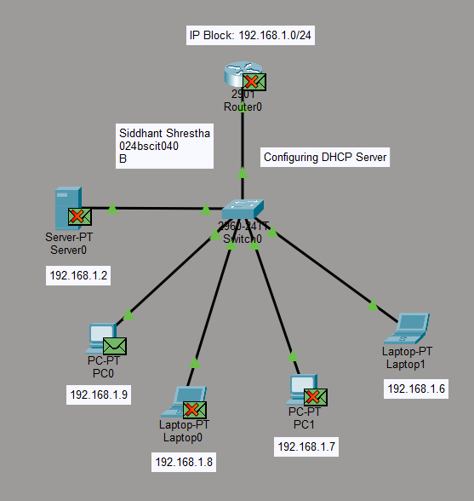

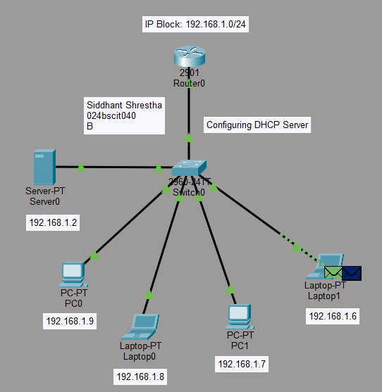
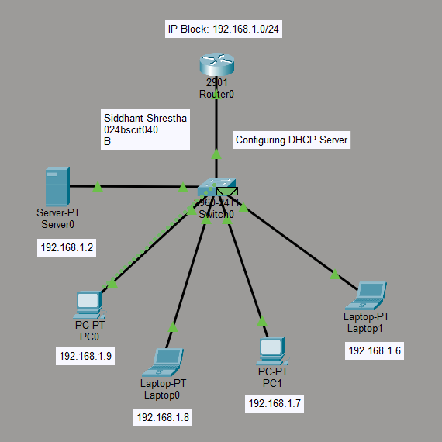

Conclusion
This lab exercise involved studying and applying various Windows networking commands to gain a practical understanding of network configuration, troubleshooting, monitoring, and management. Commands including ipconfig, ping, tracert, nslookup, netstat, and arp offered hands-on experience with network communication and diagnostic procedures.
In addition, a DHCP-based network was designed and implemented using Cisco Packet Tracer. In contrast to the static IP addressing used in Lab 1, DHCP automatically provided IP addresses and other network parameters to client devices. The successful assignment of IP addresses along with verified connectivity confirmed the efficiency and practicality of dynamic host configuration in modern networking environments.

